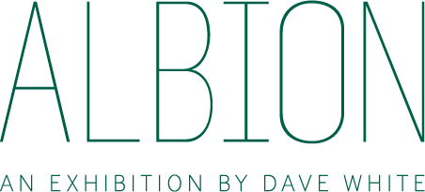

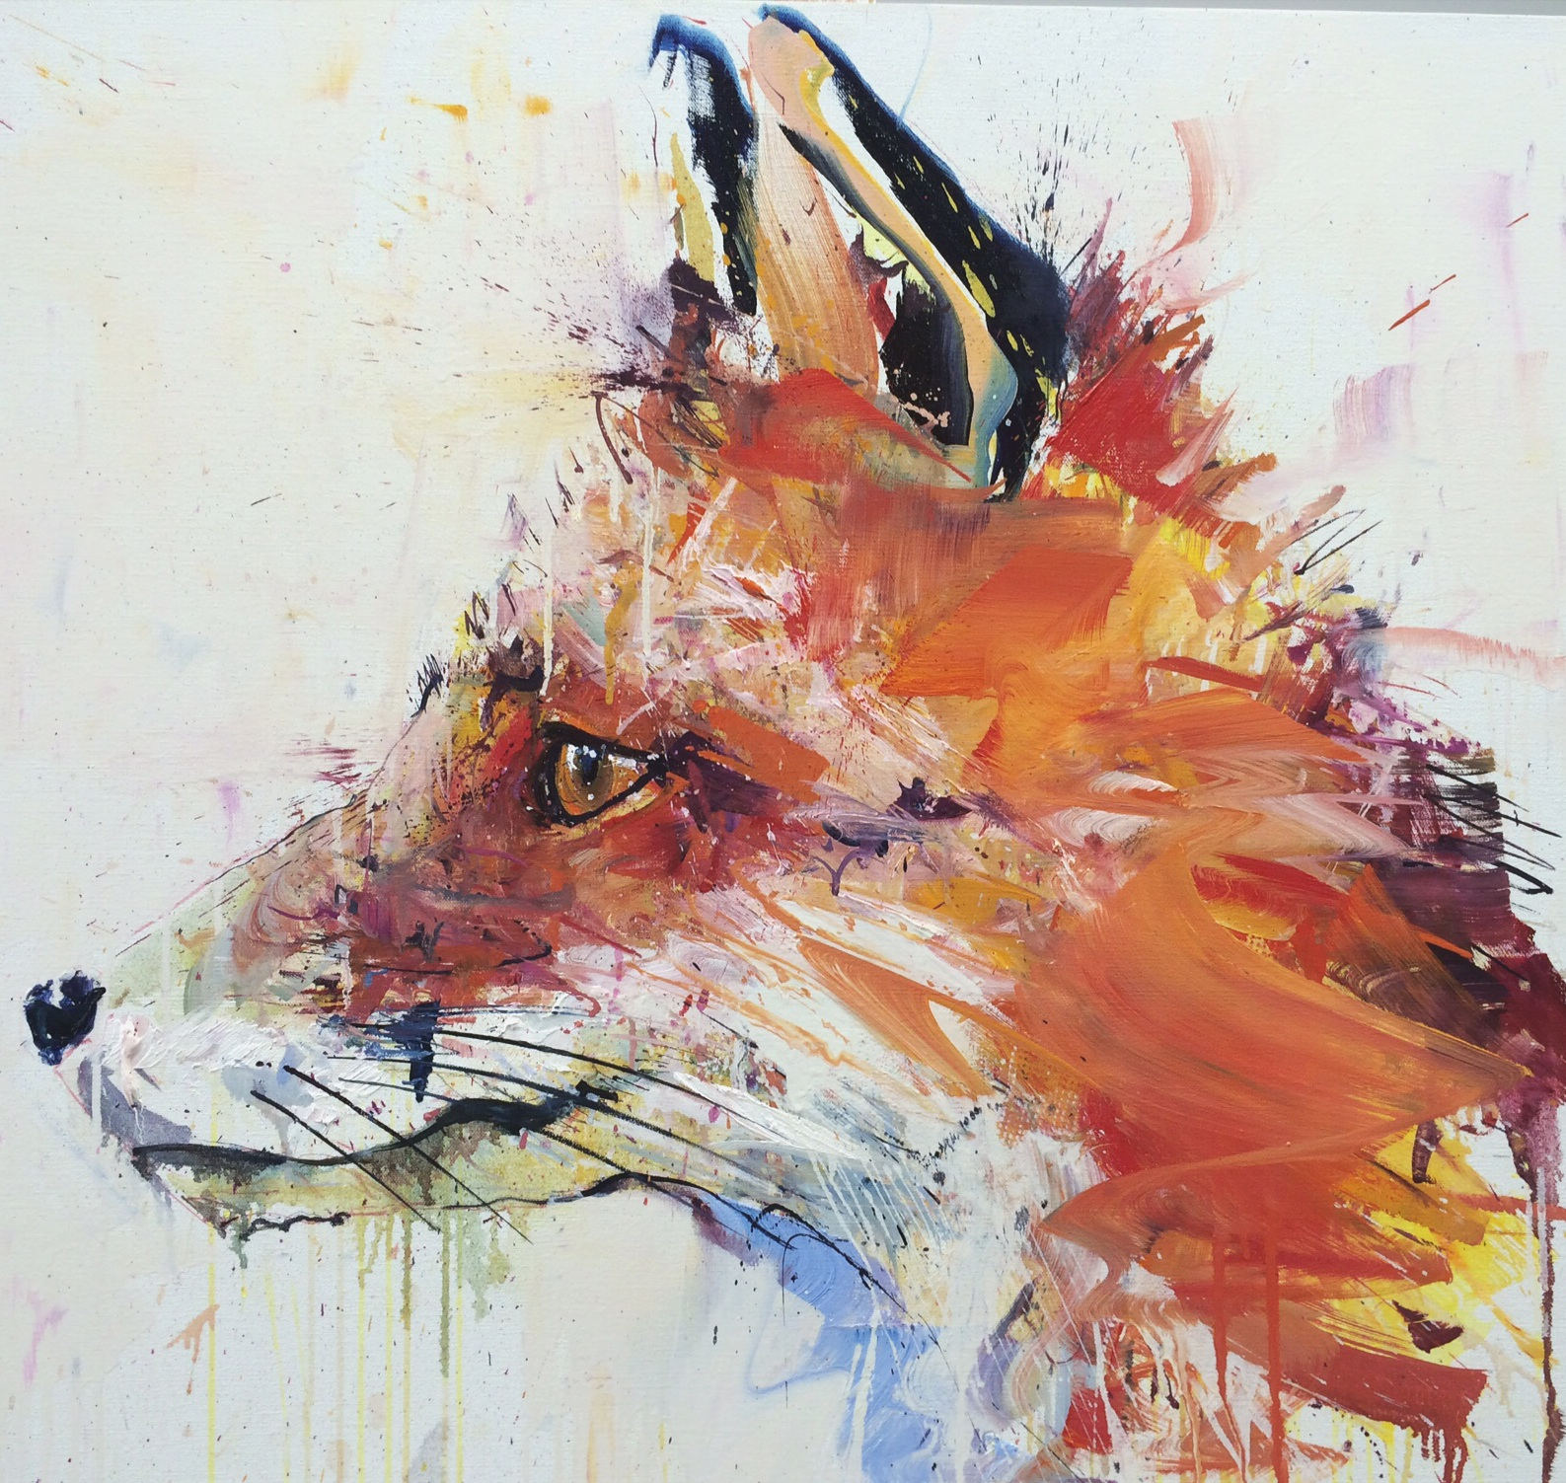
Fox II
03 July 2014
Loughran Gallery presents ‘Albion’; an Exhibition by Dave White
Loughran Gallery are proud to announce the launch of an Albion on the 8th October, an exhibition featuring the debut release of contemporary artist Dave White’s brand new collection. Following on from the success of Loughran Gallery’s exhibition programme and in succession to White’s international projects, Albion will explore the heritage and iconography of native species to Britain in White’s dynamic signature style.
The show will be a large scale installation of oil paintings, works on paper, a collectors’ box set, and limited edition silkscreen prints, exclusively unveiling White’s next subject matter celebrating classic British wildlife. The show will run for the month of October, from 8th October until 25th October, to coincide with London’s most exciting month in the art calendar. A highlight of Albion will include a classic Jaguar E-Type coupé uniquely hand-painted by the artist.
Presenting an eclectic mix of endangered and native British species, White’s aim is to challenge the viewer to re-connect with our natural world. Oversized imagery in oils with dynamic expressive qualities, signature in White’s work, present their subject matter with an intensity of movement and dynamism, which reflects the spontaneity of the natural world. On close examination, the works are almost abstract in their detail of rich oil impasto and watercolours. White presents not only beauty, but character, tension and movement in these portraits, encouraging the viewer to reflect on the obliteration of our natural wildlife through extinction and changes in our landscape.
Dave White says of the new collection: “, I would like to pay homage to our very own subjects and threatened creatures that we take for granted. Now is the time to draw attention to our much loved countryside...to celebrate it in all its glory, whilst making the viewer re-engage with the beauty that ever diminishes. It is a stark reality that species we take for granted will be gone in less than 30 years.”

-ENDS-

Notes to editors:

Loughran Gallery exhibits contemporary artists and photographers. Operating as a roaming London gallery throughout the year with a permanent exhibition space in Lancashire, Loughran Gallery’s ethos is simple: to provide a welcoming environment for finding something you love. Select artists include Blek le Rat, Chris Levine, Damien Hirst, Harland Miller, Jessica Zoob, Marc Quinn, Polly Morgan, Takashi Murakami and Tracey Emin. With eight successful shows since the gallery’s inception in 2012, Loughran Gallery has exhibited its vibrant collection of contemporary art in various locations across London. From a converted shipping location in Shoreditch to an award-winning complex on the South Bank, Loughran Gallery’s shows are unintimidating, open to all and include some of the most coveted and respected artists of today.

Dave White Dave White is a contemporary British Artist who dedicates his work to celebrating popular culture and interpreting emotive issues. He has enjoyed success from the inception of his career with selection for the Northern Graduates exhibition at the Royal College of Art. International exhibition career highlights include the People’s Square Exhibition Hall (Shanghai), Dia Art Centre (New York), Centre for Arts (Rotterdam), Art Basel Week (Miami), Truman Brewery (London), Liverpool International Biennial of Contemporary Art, New Museum of Contemporary Art (New York) on the Project on Creativity with Chuck Close, Hospital Club Gallery (London) and the Goss Michael Foundation (Dallas) for MTV RE:DEFINE with The Future Tense. White’s most recent project was a solo exhibition in Los Angeles and he has another in China to be announced later in the year.

IRIS The show will be held in one of London’s most cosmopolitan areas at IRIS Studios. With a refreshing, modern approach, the state of the art Eco complex features two contemporary studios providing the perfect location for events. Though in central London, IRIS is intrinsically tranquil. Tireless effort has been spent to ensure that every inch of the space here is conducive to creativity and calm – a crisp white blank canvas awaiting the artist.
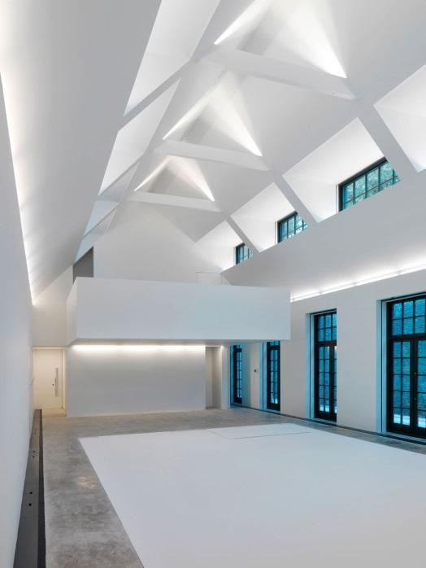

Loughran Gallery, Iris Studios, Adrian Mews, London, SW10 9AE
Opening Times: Monday – Saturday 10am - 7pm

For more information please contact:
Anna Symons
anna@dundascommunications.com 020 7233 6425
Josie Latham
josie@dundascommunications.com 020 7233 6425

